**Steps for Asleep App**

1. Build out structure

1. Create title panel

1. Create sidebar layout with sidebar and main panel

1. Create first input: selectInput()

1. Create second input: numericInput()

1. Create third input: numericInput()

1. Create fourth input: selectInput()

1. Create action button

1. Create server logic (will not display probabilities at this step because output not in UI)

1. Display probability on main panel

**Outputs**

If you would like to run the app after completing each step, the outputs are below:

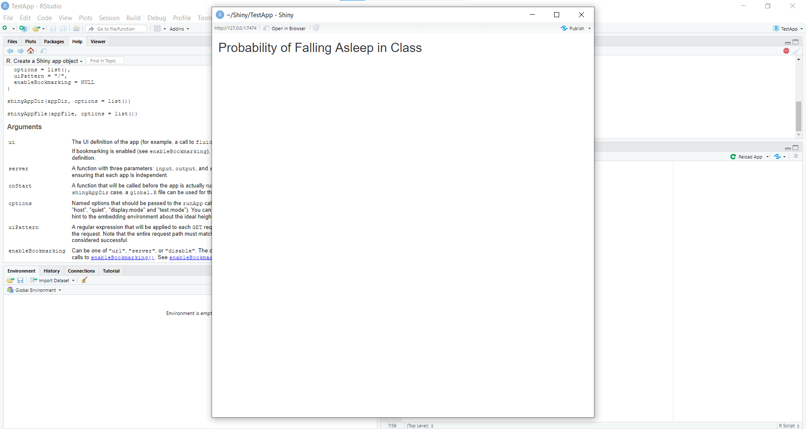

Figure 1: Step 2 output; title created

Figure 2: Step 3 output; sidebar layout created with side panel and main panel

Figure 3: Step 4 output; coffee drop-down created

Figure 4: Step 5 output; input box created for hours of sleep

Figure 5: Step 6 output; input box created for age

Figure 6: Step 7 output; drop-down menu created for enjoying the material

Figure 7: Step 8 output; submit button created

Figure 8: Step 10 output; displaying probability on user interface